TC08

**Test Scenario:** ESS User able to add photograph

**Test Case Title:** Verify ESS is able to add Phtograph

**Test Case Steps:**

1) Launch bowser

2) Login to OrangeHRM web portal

3) Click on My Info

4) Click on Profile

5) Under About section you can add photograph by clicking on photo at corner

6) Click on change button and select photograph. ( Supported formats are JPG, PNG and GIF. Maximum allowed size for photograph is 1 MB)

7) Click on save button

8) Check whether photograph is changed/uploaded or not.

**Default Photograph :**

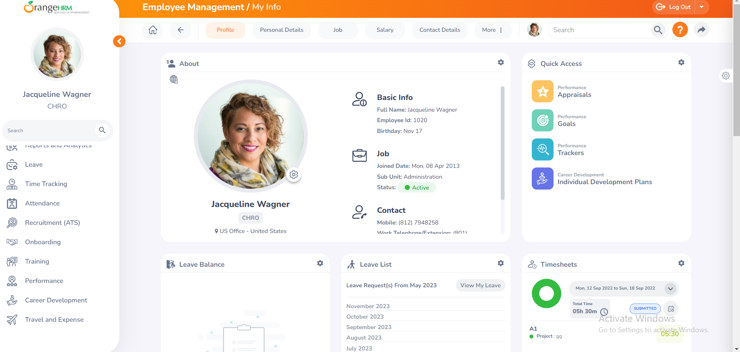

**After clicking on photo at corner we will find photograph change option as below :**

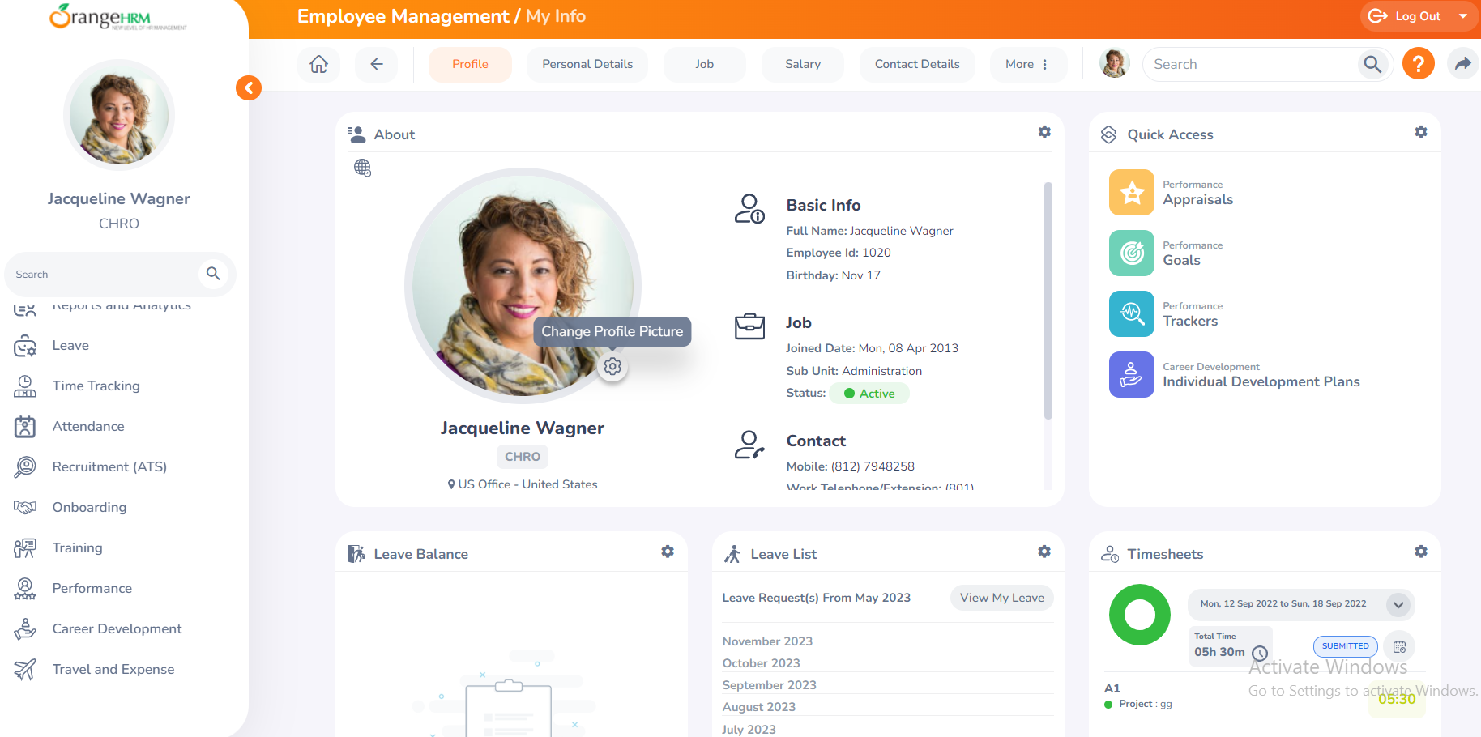

**Now Let’s click on Change profile picture option to change/add photograph :**

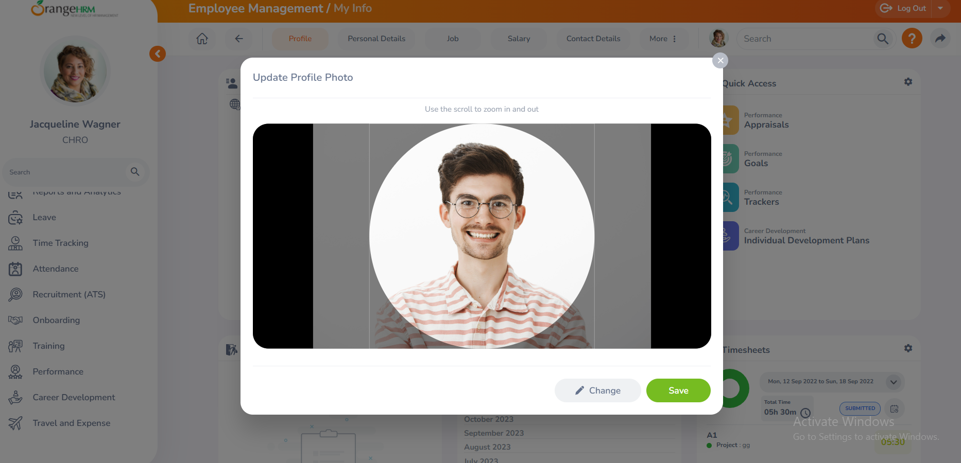

**Now we can see that our photograph has been uploaded successfully. Photograph size was 918 KB and format was jpg :**

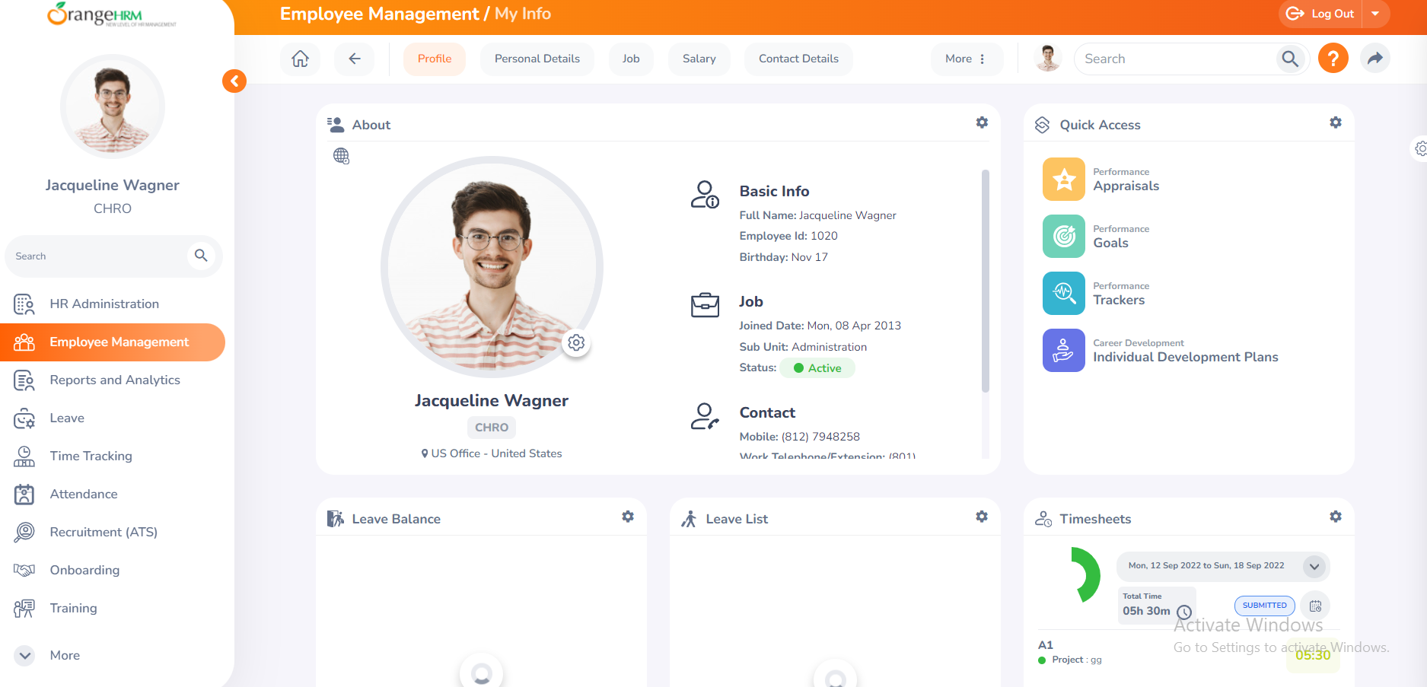

**Used photograph :**

